Date of Publication XXXX 00, 0000, Date of Current Version XXXX 00, 0000.
Digital Object Identifier 10.1109/ACCESS.XXXX.Doi Number
Preparation of Papers for KJAISE Journal
First A. Author¹, Second B. Author², and Third C. Author, Jr.³
1Department of Physics, Qaiwan International University, Erbil, Kurdistan Region, Iraq
2Department of Electrical Engineering, Qaiwan International University, Erbil, Kurdistan Region, Iraq
3Department of Computer Science, Qaiwan International University, Erbil, Kurdistan Region, Iraq
Corresponding Author: First A. Author (e-mail: author@uniq.edi.iq).

ABSTRACT These instructions provide guidelines for preparing papers for KJAISE Journal. Use this document as a template if you are using Microsoft Word. Alternatively, follow these instructions for formatting your manuscript. The electronic file of your paper will be formatted further by the editorial team. Paper titles should be written in title case (uppercase and lowercase letters), not all uppercase. Avoid lengthy formulas with subscripts in the title; short formulas identifying elements are acceptable (e.g., “Nd–Fe–B”). Do not include “(Invited)” in the title. Full names of authors are preferred but not mandatory. Include a space between authors’ initials. The abstract must be a concise yet comprehensive summary of your article, written as one paragraph (150–250 words). It should be self-contained, without abbreviations, footnotes, or references. Avoid displayed mathematical equations or tabular material. Include 4–6 keywords or phrases to aid indexing. Ensure the abstract is grammatically correct and free of over-repetition.
KEY WORDS: List 4-6 key words or phrases in alphabetical order, separated by commas.
I. INTRODUCTION
This document serves as a template for preparing manuscripts for KJAISE Journal. If you are using Microsoft Word, follow the formatting guidelines provided. For LaTeX users, please make sure to follow the author guideline.
II. GUIDELINES FOR MANUSCRIPT PREPARATION
When preparing your manuscript, use the KJAISE Journal template. Type over sections or copy and paste from another document, applying the appropriate styles from the formatting toolbar. Do not alter font sizes or line spacing to fit more text. Use italics for emphasis; avoid underlining.
To insert images, position the cursor at the insertion point and use Insert > Picture > From File or copy the image to the clipboard and paste it as a picture. Ensure figures and tables are high-resolution and properly labeled.
A. ABBREVIATIONS AND ACRONYMS
Define abbreviations and acronyms the first time they are used in the text, even if defined in the abstract. Common abbreviations like IEEE, SI, ac, and dc do not require definition. Avoid abbreviations in the title unless necessary.
B. OTHER RECOMMENDATIONS
- Use one space after periods and colons.
- Hyphenate complex modifiers (e.g., “zero-field-cooled magnetization”).
- Avoid dangling participles (e.g., “Using ($1$), the potential was calculated”). Instead, write, “The potential was calculated using (1).”
- Use a zero before decimal points (e.g., “$0.25$,” not “$.25$”).
- Use “$cm³$,” not “cc.”
- Indicate sample dimensions as “$0.1 cm × 0.2 cm$,” not “$0.1 × 0.2 cm²$.”
- Use “$s$” for seconds, not “$sec.$”
- Use “$Wb/m²$” or “webers per square meter,” not “$webers/m²$.”
- For ranges, write “$7 to 9$” or “$7-9$,” not “$7\sim 9$.”
- Punctuate parenthetical statements outside the closing parenthesis (like this).
- Use serial commas (e.g., “A, B, and C”).
III. MATH
Use the Microsoft Equation Editor or MathType for equations. Number equations consecutively, flush with the right margin, as in (1). Italicize symbols (e.g., $T$ for temperature). Refer to equations as “(1),” not “Eq. (1),” except at the beginning of a sentence.
IV. UNITS
Use SI (MKS) or CGS units. English units may be used as secondary units in parentheses. Avoid combining SI and CGS units in equations. Clearly state units for each quantity.
V. SOME COMMON MISTAKES
- “Data” is plural, not singular.
- Use “micrometer,” not “micron.”
- Use “remanence,” not “remnance.”
- Avoid confusing homophones like “affect” (verb) and “effect” (noun).
- Prefixes like “non,” “sub,” and “micro” should be joined to the words they modify without a hyphen.
VI. GUIDELINES FOR GRAPHICS PREPARATION
A. FIGURES
- High-resolution (300 dpi minimum) in TIFF, PNG, or JPEG format.
- Use clear, legible fonts for labels and axes (e.g., Arial, 10-point).
- Color figures are encouraged but must be interpretable in grayscale.
- Include a brief, descriptive caption below each figure.
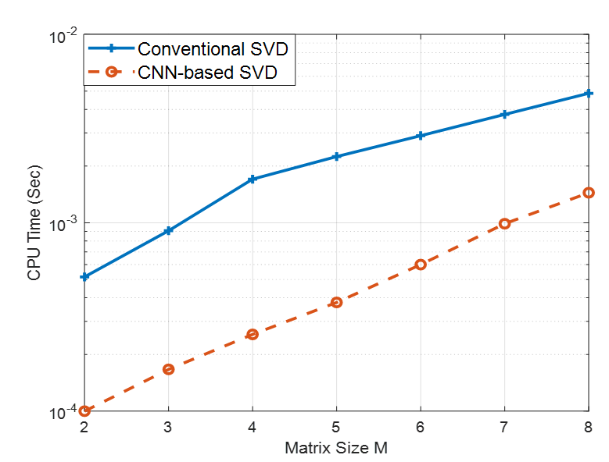

FIGURE 1: Time complexity analysis for calculating singular values using both CNN-based SVD and the conventional SVD algorithm across varying matrix sizes.

B. TABLES
- Use Word’s table tool or LaTeX. Avoid images of tables.
- Number tables sequentially (e.g., Table 1, Table 2).
- Include a brief, descriptive caption above each table.
- Use horizontal lines only; avoid vertical lines.

C. PLACEMENT
- Indicate the approximate placement of figures and tables in the text (e.g., “Insert Figure 1 here”).
- Ensure that figures and tables are referenced in the text.

TABLE I
Units for Magnetic Properties
Symbol | Quantity | Conversion from Gaussian and  CGS EMU to SI ª
Φ | magnetic flux | 1 Mx → 10⁻⁸ Wb = 10⁻⁸ V·s
B | magnetic flux density,  magnetic induction | 1 G → 10⁻⁴ T = 10⁻⁴ Wb/m²
H | magnetic field strength | 1 Oe → 10³/(4π) A/m
m | magnetic moment | 1 erg/G = 1 emu  → 10⁻³ A·m² = 10⁻³ J/T
M | magnetization | 1 erg/(G·cm³) = 1 emu/cm³  → 10³ A/m
4πM | magnetization | 1 G → 10³/(4π) A/m
σ | specific magnetization | 1 erg/(G·g) = 1 emu/g → 1 A·m²/kg
j | magnetic dipole  moment | 1 erg/G = 1 emu  → 4π × 10⁻¹⁰ Wb·m
J | magnetic polarization | 1 erg/(G·cm³) = 1 emu/cm³  → 4π × 10⁻⁴ T
χ, κ | susceptibility | 1 → 4π
χ_{ρ} | mass susceptibility | 1 cm³/g → 4π × 10⁻³ m³/kg
μ | permeability | 1 → 4π × 10⁻⁷ H/m  = 4π × 10⁻⁷ Wb/(A·m)
μ_{r} | relative permeability | μ → μ_{r}
w, W | energy density | 1 erg/cm³ → 10⁻¹ J/m³
N, D | demagnetizing factor | 1 → 1/(4π)
Vertical lines are optional in tables. Statements that serve as captions for the entire table do not need footnote letters.
ªGaussian units are the same as cg emu for magnetostatics; Mx = maxwell, G = gauss, Oe = oersted; Wb = weber, V = volt, s = second, T = tesla, m = meter, A = ampere, J = joule, kg = kilogram, H = henry.
VII. CONCLUSION
The conclusion should provide a concise summary of the main findings and insights of the paper without merely restating the abstract. Instead, it should highlight the significance of the research, discuss its broader implications, and suggest potential applications or future directions. Authors may also address any limitations and propose areas for further investigation.
APPENDIX
Appendixes, if needed, appear before the acknowledgment.
ACKNOWLEDGMENT
Acknowledge funding sources, contributors, or institutions. Use the singular heading “Acknowledgment” even for multiple acknowledgments.
REFERENCES
- In-text citations: Number citations sequentially in square brackets (e.g., [1], [2]). Place citations before punctuation (e.g., “as shown in [1].”).
- Reference list: Number references in the order of citation and include full details:
- Journal Article: [1] A. Author, “Title of the paper,” Journal Name, vol. xx, no. xx, pp. xxx–xxx, Year.
- Book: [2] A. Author, Title of the Book, Edition. City, Country: Publisher, Year.
- Conference Paper: [3] A. Author, “Title of the paper,” in Proc. Conference Name, City, Country, Year, pp. xxx–xxx.
- Website: [4] A. Author, “Title of the webpage,” Website Name, Year. [Online]. Available: URL. [Accessed: Month Day, Year].
- Ensure all references are complete and accurate.
VIII. SUBMITTING YOUR PAPER FOR REVIEW
- Register and submit your manuscript via the KJAISE online submission system.
- Ensure all files (manuscript, figures, supplementary materials) are uploaded correctly.
- Remove all identifying information from the manuscript (e.g., names, affiliations, acknowledgments).
- Use “Author” and year in place of names in citations (e.g., [Author, Year]).
- Ensure that the manuscript file properties do not contain author information.
- Include a cover letter summarizing the significance of the work and confirming that it has not been submitted elsewhere.
- Provide a list of suggested reviewers (optional) and any reviewers to exclude (if applicable).
IX. KJAISE PUBLISHING POLICY
Originality and Prior Publications
Authors must submit only original and unpublished work that is not under review by any other journal. Any prior publications or concurrent submissions must be disclosed at the time of submission. Preliminary data or incomplete results should not be submitted.

Authorship and Responsibilities
The corresponding author is responsible for ensuring that all co-authors have approved the submission and that any necessary permissions from employers or sponsors have been obtained. KJAISE Journal discourages honorary or courtesy authorship; all listed authors must have made a significant contribution to the research. Authors must properly acknowledge and cite relevant prior work.

Conference Papers
KJAISE Journal does not publish conference proceedings. However, articles based on conference presentations may be considered for publication if they have undergone significant revision and expansion and meet the journal's peer review standards. All submissions undergo a rigorous double-blind peer review process, with a minimum of two independent reviewers per article.

COPYRIGHT FORM
Authors are required to submit an electronic Copyright Transfer Agreement (CTA) upon submitting their final manuscript files. The CTA can be accessed through the KJAISE Journal submission system or the author portal. It is the responsibility of the authors to obtain any necessary approvals, permissions, or security clearances before submission. For further details regarding intellectual property rights, please visit the KJAISE Journal website or contact the editorial team for assistance.

